Name : Khushi Panwar

SEC (Python) PRACTICAL ASSIGNEMENT : 06.10.2022

Computer Science (3rd Sem)

**Question 10 (From Practical List ) : WAF that takes a sentence as input form the user and calculates the frequency of each letter. Use a variable of dictionary type to maintain the count**

**Solution →**

line=input("Enter a sentence here : ")

lst=list(x for x in line)

lst.sort()

d={}

for i in range(len(lst)):

count=0

new_key=lst[i]

for j in range(len(lst)):

if lst[i]==lst[j]:

count+=1

d.update({new_key: count})

print("\n -> The freqeuncy of letters is as : ")

for i in d:

if (i==" "):

print("Space : ", d[i] )

else:

print(i, " : ", d[i])

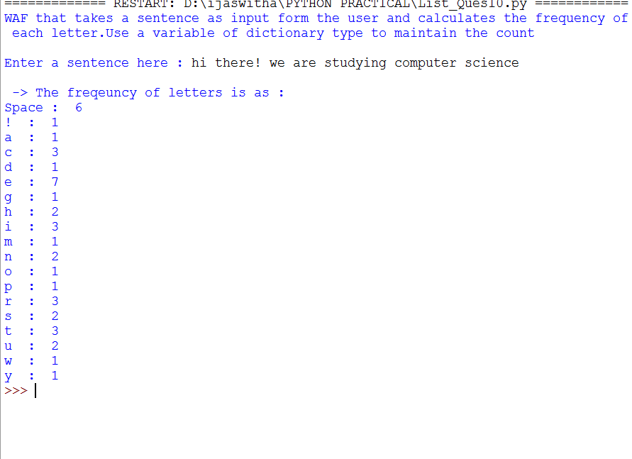

**Question 12 (From Practical List ) :** **WAP that makes use of a function to accept a list of n integers and displays a histogram**

**Solution →**

import matplotlib.pyplot as plt

print("WAP that makes use of a function to accept a list of n integers and displays a histogram \n")

lst=list(map(int, input("Enter the n numbers : ").split()))

plt.hist(lst, bins = 10)

plt.show()

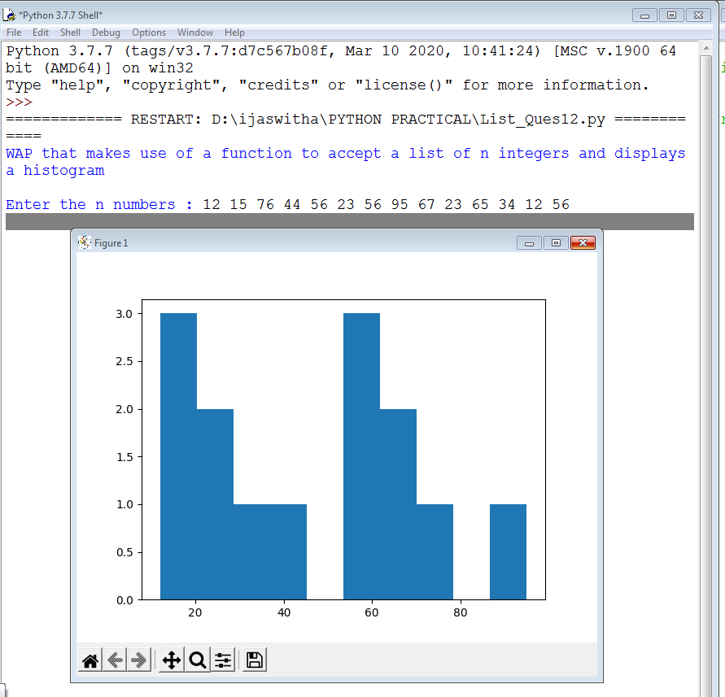

**Question 13 (From Practical List ) : WAP that makes the use of a function to display sine, cosine, polynomial and exponential curves.**

**Solution →**

import matplotlib.pyplot as plt

import numpy as np

#showing sine curve

x = np.arange(0,4*np.pi,0.1) # start,stop,step

y = np.sin(x)

plt.plot(x, y)

plt.show()

#showing the cosine curve

z = np.cos(x)

plt.plot(x,y,x,z)

plt.show()

#comparing sin and cosine curve together

x = np.arange(0,4*np.pi,0.1) # start,stop,step

y = np.sin(x)

z = np.cos(x)

plt.plot(x,y,x,z)

plt.show()

